TITLE OF THE WORK IN UPPERCASE BOLD FONT, SIZE 14.
Author1
Author2

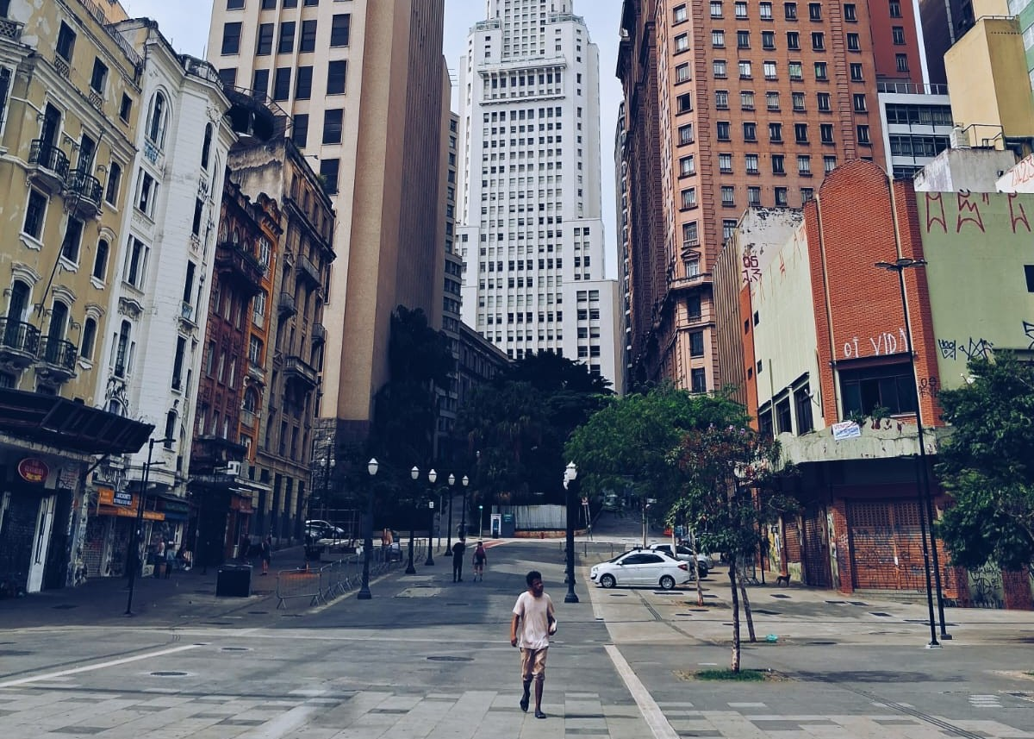

The photograph must be inserted into the template exactly as indicated.

Below the image, a brief explanatory text about the photograph is mandatory. This text may be descriptive or, primarily, conceptual. Both the image and the text will be part of the Cine-Forum Exhibition. The text should contain a maximum of 5 lines in Times New Roman 12pt, 1.5 spacing, and justified text.

It is mandatory to submit a link containing the high-definition photograph. This link must direct you to the high-resolution file, allowing you to download it for later inclusion in the virtual exhibition.

The artwork should have a maximum of 2 authors.

By submitting the template, the author authorizes the use of the image exclusively for display purposes at the Cine-Forum Exhibition, while reserving the right to request the removal of the work at any time, upon request.

Photo of the author on the second page of the template.
Below the photo, add a short biography of the author, maximum 10 lines, in Times New Roman 12pt font, 1.5 spacing, justified.

Add a link (via Google Drive or another cloud service) to the photo in very high resolution, such as:
- of the image/photograph/drawing
- From the author:
Add link(s) here:

